Thomas Stacey 3146

The Royal Latin School  52131

h446 component 3: Empire Game Project

Contents

Introduction 1

Analysis 1

Computational Methods 1

Stakeholders 1

Existing Solutions 1

Common Features 1

Sid Meier’s Civilization III 2

Sid Meier’s Civilization V 2

Sid Meier’s Civilization: Beyond Earth 2

Sid Meier’s Civilization VI 3

My Approach 3

Essential Features 3

Limitations 4

Requirements 4

Success Criteria 4

Design 4

# Introduction

For my H446 Project, I will be making a 4K strategy game similar to the “Sid Meier’s Civilization” Series. The game will revolve around managing an empire of cities against other players and AI using different types of units. I will be building the game in the Unity Engine, which will allow me to easily compile to different operating systems.

# Analysis

## Computational Methods

This problem is able to be solved through computational methods, as it is primarily a video game. Part of the game involves moving units around, which could be done more efficiently by the user by using a “shortest path” algorithm such as the A* algorithm, allowing less experienced users to avoid terrain penalties they may not notice along the way. Using computers also allows for automation of tasks such as workers and explorers which would need to be done manually if this were a table top game instead.

AI opponents are another feature that requires computers in order to be implemented, without which the game would not be enjoyable, as there would be no objectives and no win conditions.

## Stakeholders

The stakeholders for my project are people who enjoy playing strategy games similar to civilization. The game will give players a new experience that feels familiar but also has new features allowing for the players to enjoy the project without feeling it is simply a copy of an existing game.

## Existing Solutions

Existing solutions to this problem include the titles from the “Sid Meier’s Civilization” series, as well as other games such as “Pandora: First Contact”. These solutions employ various differences, but also have many things in common.

### Common Features

There are multiple features which are common to all the existing games that I am looking at. These approaches include turns, so that no player has much of an advantage over another and tiles to separate the map into playable sections. The maps are generally composed of islands similar to our own planet, with different land types to make the game more interesting. There are also different types of units which can move around the map and cities which act as producers for units and targets for capture. Multiple win conditions allow the games to have multiple different playstyles which all have an equal chance of victory. Most games also have a tech tree, which allows the unlocking of new units and other features, allowing the game to progress rather than remaining static.

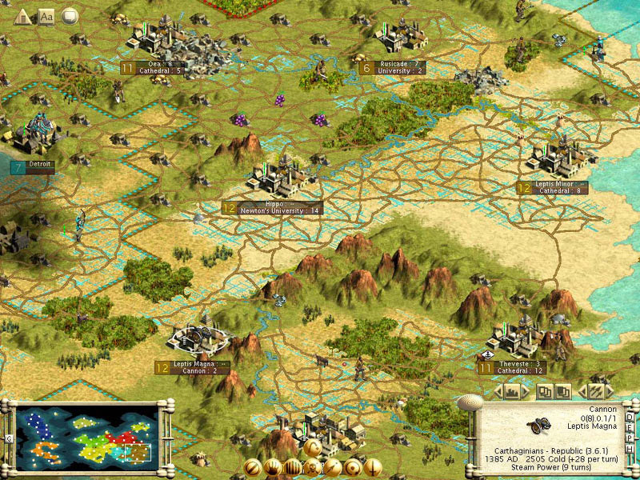

### Sid Meier’s Civilization III

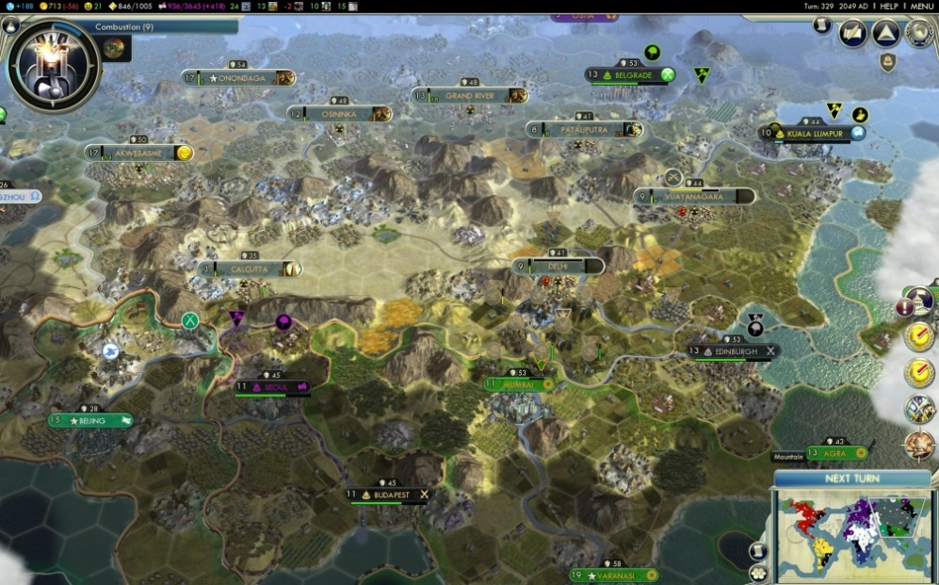Civilization III is an older title, and as such contains features that can be improved upon. These include the use of square tiles meaning that all movements are not equal, and land units being unable to cross water on their own. This, while more realistic becomes potentially frustrating for the player, and I believe later games have better solutions. Civ III also allows unlimited units on one tile, which can cause balance issues during wars. Its semi-realistic style has charm, and also allows the game to run on much lower end machines

### Sid Meier’s Civilization V

Civilization V has a much more realistic style, which, while looking better also means that the computer running it needs to be much more powerful than Civ III. It uses hexagon tiles, a staple of later games of this type as it allows for equal movement in six directions. It also introduces ideologies, a late game feature which allows more specialisation into certain paths.

### http://core0.staticworld.net/images/article/2014/10/2014-10-16_00032-100526286-orig.jpgSid Meier’s Civilization: Beyond Earth

Beyond Earth has a space setting; however has fairly similar mechanics to previous Civilization games. It does add a few unique features however, such as miasma, a tile modifier which causes damage to units, a tech web rather than a tree, which allows for a more customised path, and affinities which each have their own benefits and weaknesses.

### http://cdn2.gamepur.com/images/civilization_6/civilization_6_map_screenshot3.JPGSid Meier’s Civilization VI

Civ VI has a cartoon style, but is more detailed, so the benefits of using this style in Civilization III are lost, making it simply a thematic decision. It adds features such as ‘breakthroughs’, which give a boost to certain researches, and multi-tile cities through ‘districts’, meaning that more thought has to be put into placement, increasing the difficulty for both old players (who may enjoy the challenge), and new players (potentially putting them off)

### My Approach

In my game, I will be taking features from each of the games I have analysed in order to create a more well-rounded final product. I will be using a simpler style like that of Civilization III in order to reduce performance costs, but hexagon tiles in order to create a more balanced game. Land units will be able to cross into water, but will have lower health and attack damage whilst embarked in order to balance. I will integrate breakthroughs into the game to allow for a more interesting game, but will not be including districts, as I feel that they are more complex and therefore off-putting to new players.

## Essential Features

* Tile Based
  + Using Hex tiles as this allows for equal movement cost regardless of direction
  + Different types of tiles
  + Tiles have movement cost
  + Water tiles & ships
* Map Generation
  + Generates a reasonable map
* Different civilizations
  + Each have different abilities so not all the same
  + Player can choose one or choose random
  + AI Players to fill map
* Revolutions
  + Unique Feature
  + Unhappy areas far from capital can revolt
  + Can join another civ or become independent
    - Independent civ needs name
      * Based on area / city name / defined options based on civ succeeds from
    - Independent civ auto declare war unless peaceful independence agreed
* Combat
  + Units can fight each other
  + Element of randomness
* Territory
  + Cities hold territory around them
  + Borders can prevent passage of troops
* Units
  + Different units with different abilities
  + Settler can found cities
  + Worker does work, builds improvements etc.
  + Various military units with different stats
  + “Great People” provide boosts in different stats

## Limitations

Maps can only be a certain size due to want to load whole map at once

## Requirements

* Needs GPU in order to render graphics
* Needs to be able to run Unity games

## Success Criteria

* TODO

# Design